

**FORE SCHOOL OF MANAGEMENT**

**NEW DELHI**

**Academic Session: 2023-2025**

**Machine Learning for Managers – II**

**“Segmentation of Employee Compensation Data”**

**PGDM 32 Section: A**

**Submitted to: Submitted by:**

**Prof. Amarnath Mitra Arushi Khanna**

**Roll No.: 321012**

**TABLE OF CONTENTS**

|  |  |
| --- | --- |
| **Sr. No.** | **Content** |
| 1. | Project Objective |
| 2. | Data Description |
| 3 | Data Analysis |
| 4. | Results and Observation |
| 5. | Managerial Insights |

1. **Project Objective**

→ Segmentation of Employee Compensation Data using Unsupervised Machine Learning Clustering Algorithms

→ The second objective is to identify the number of appropriate clusters using a performance matrix (Silhouette score).

→ The third objective is to determine the characteristics of each cluster

1. **Data Description**

2.1 Dimension of Data

2.1.1 Data Source: https://www.kaggle.com/datasets/san-francisco/sf-employee-compensation

2.1.2 Data Size: 26 MB (Kaggle), 153 MB (Excel csv File)

2.1.3 Number of Variables: The number of variables in the csv file is 22.

2.1.4 Number of records: The number of records in the csv file is 6,83,277 (excluding naming column).

**2.2 Description of Variables**

Index Variables:

Organization Group Code: Gives the organisation groups an identification

Job Family Code: Gives the Job families an identification

Job Code: Gives the particular from a Job Family an identification

Year: The particular year for the variables and records

Department Code: An identifier for a department in an organisation

Union Code: An identifier for a particular union

Employee Identifier: An employee’s identification code

Categorical Variables:

|  |
| --- |
| Year Type |
| Organization Group |
| Department |
| Union |
| Job Family |
| Job  Non – Categorical Variables: |
| Salaries |
| Overtime |
| Other Salaries |
| Total Salary |
| Retirement |
| Health and Dental |
| Other Benefits |
| Total Benefits |
| Total Compensation |

2.3 **Descriptive Statistics**

2.3.1 Descriptive Statistics: Categorical Variables

2.3.1.1 Year type

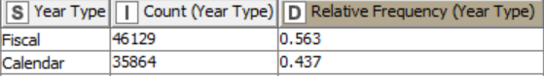

2.3.1.2 Organisation Group

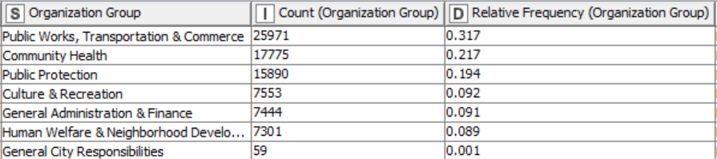

2.3.1.3 Department

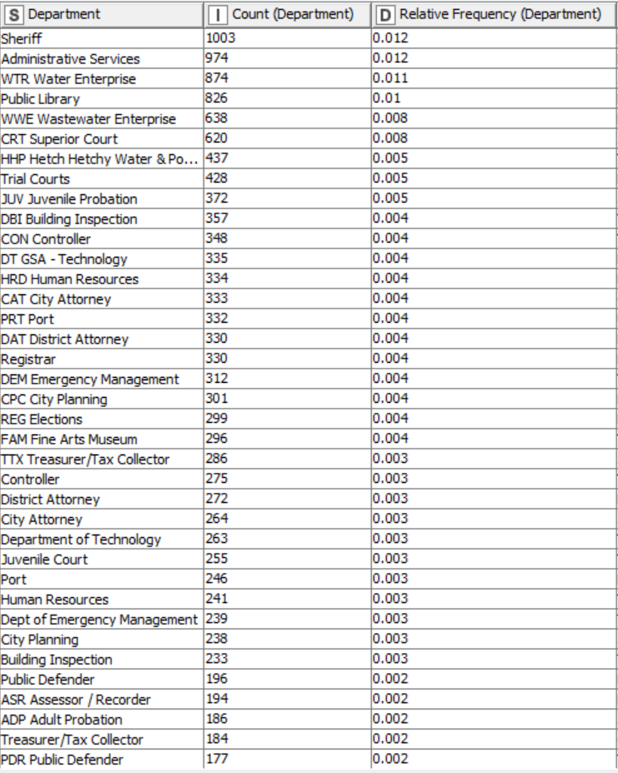

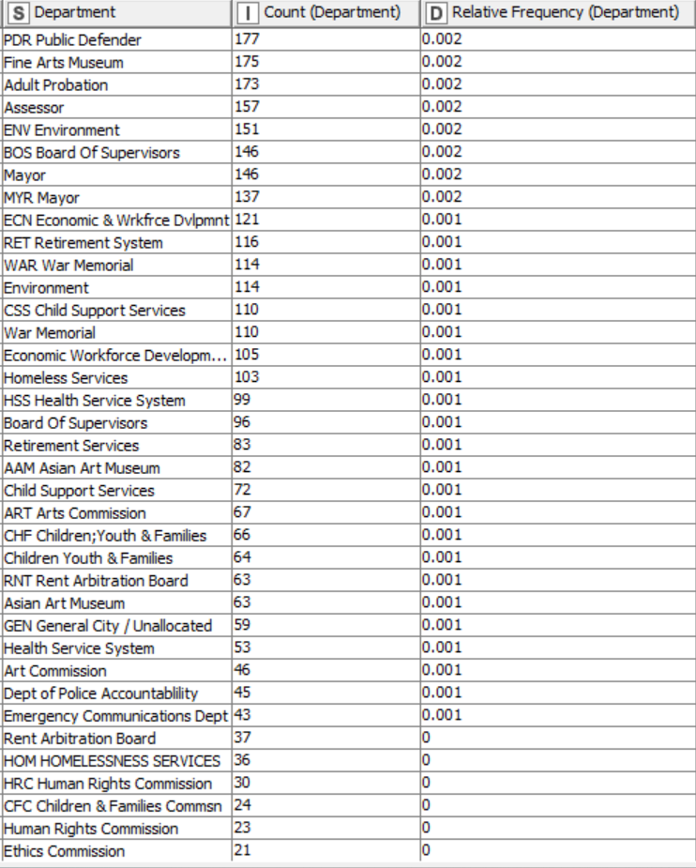

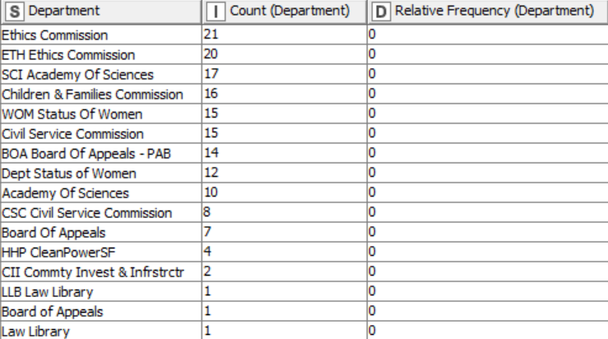

2.3.1.4 Union

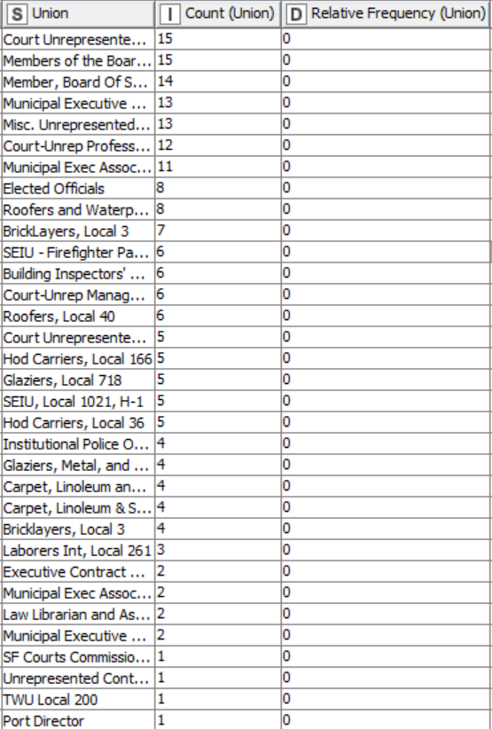

2.3.1.5 Job Family

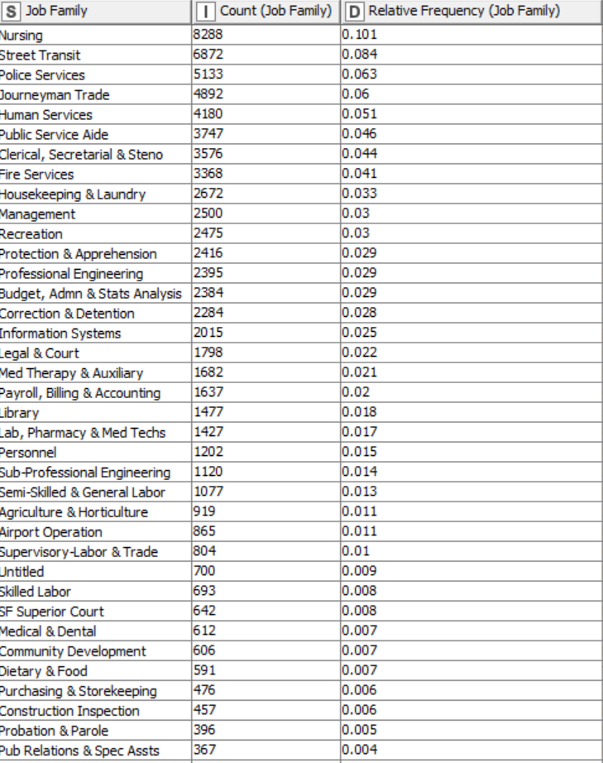

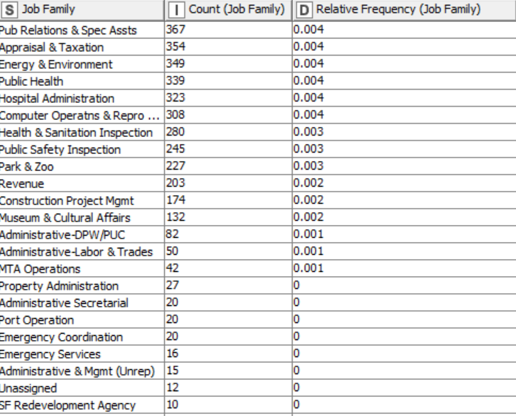

2.3.1.6 Job

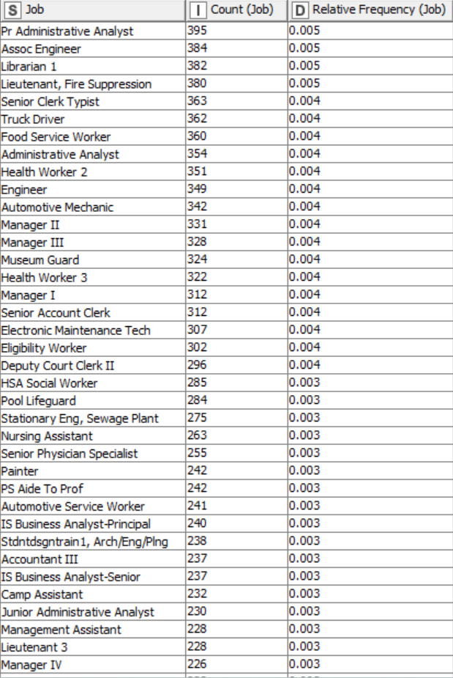

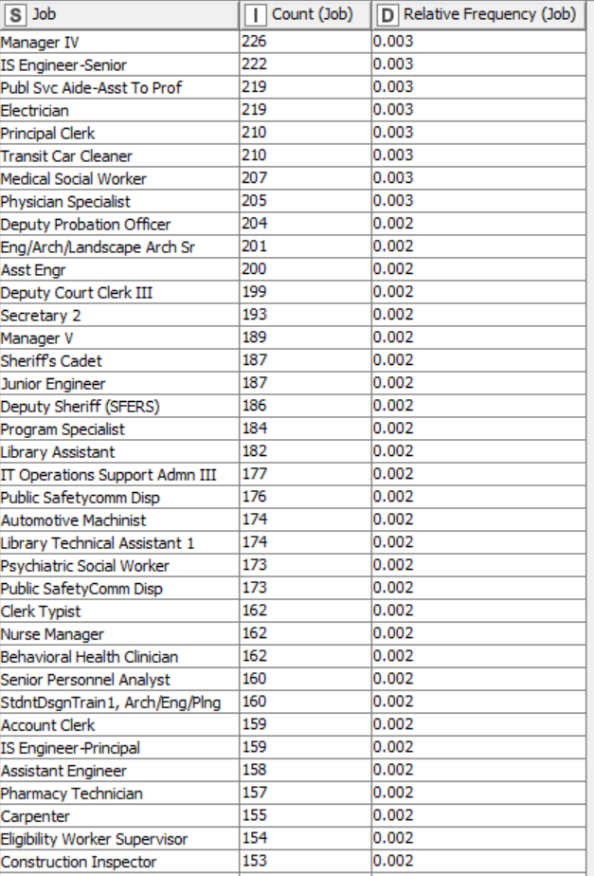

And so on and so forth

2.3.2 Descriptive Statistics: Non-Categorical Variables

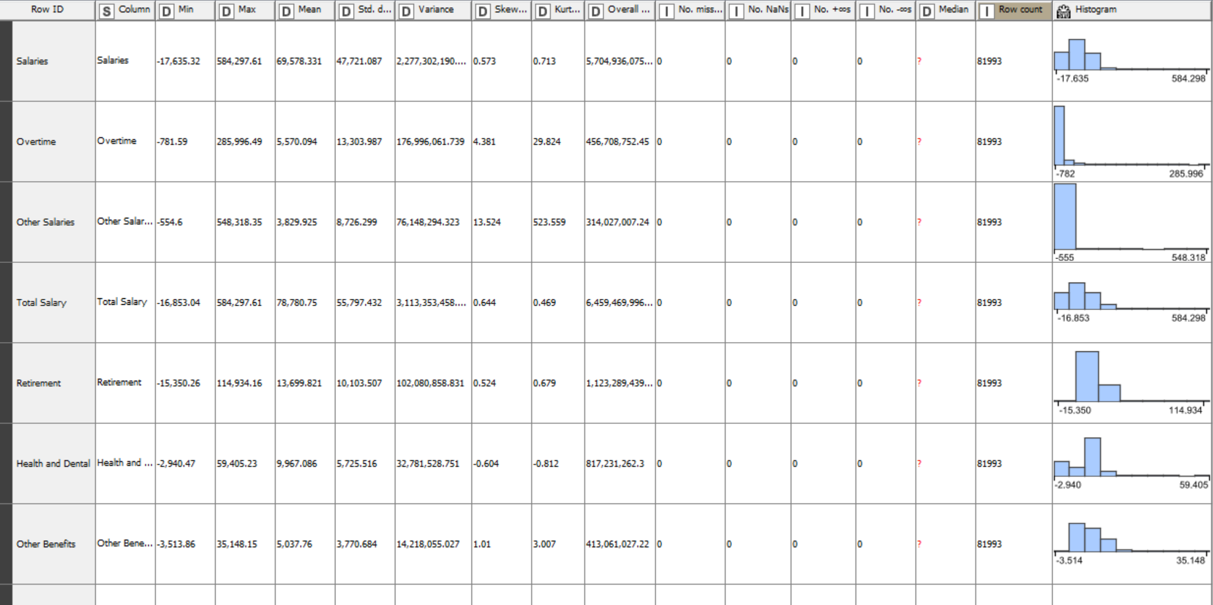

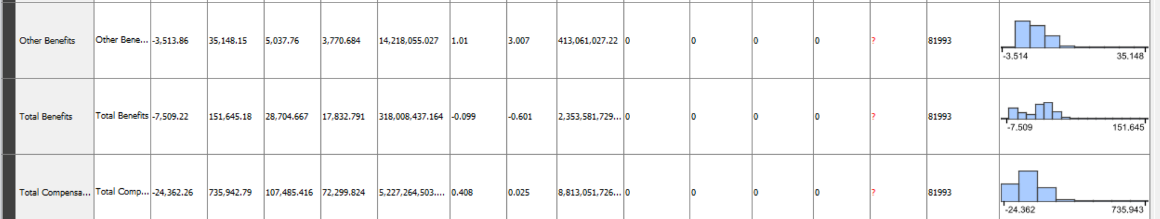

1. **Analysis Of Data**

3.1 Data Pre-Processing

3.1.1 Missing Data Statistics and Treatment

3.1.1.1 Missing Data Statistics: 0

3.1.1.2 Missing Data Treatment: 0

3.1.1.2.1 Removal of Records with More Than 50% Missing Data: None

3.1.1.3 Missing Data Statistics of categorical Variables: 0

3.1.1.3.1 Missing Data Treatment: Categorical Variables or Features: 0

3.1.1.3.1.1 Removal of Variables or Features with More Than 50% Missing Data: None

3.1.1.4 Missing Data Statistics of non-categorical Variables: 0

3.1.1.4.1 Missing Data Treatment of non-categorical Variables: 0

3.1.1.4.1.1 Removal of Variables or Features with More Than 50% Missing Data: None

**3.1.2 Numerical Encoding of Variables**

In this case, category to variable node will be used to encode categorical data into numbers such as:

Year Type:

Calendar = 0, Fiscal = 1

Organization Group:

Public Protection = 0

Public Works, Transportation & Commerce = 1

Human Welfare & Neighbourhood Development = 2

Community Health = 3

Culture & Recreation = 4

General Administration & Finance = 5

And so on and so forth

3.1.3 Outlier Statistics Treatment

3.1.3.1 Outlier Statistics: Non-Categorical Variables

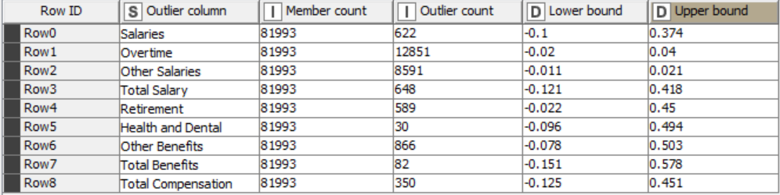

3.1.3.2 Normalization using Min-Max Scaler

Before Normalization

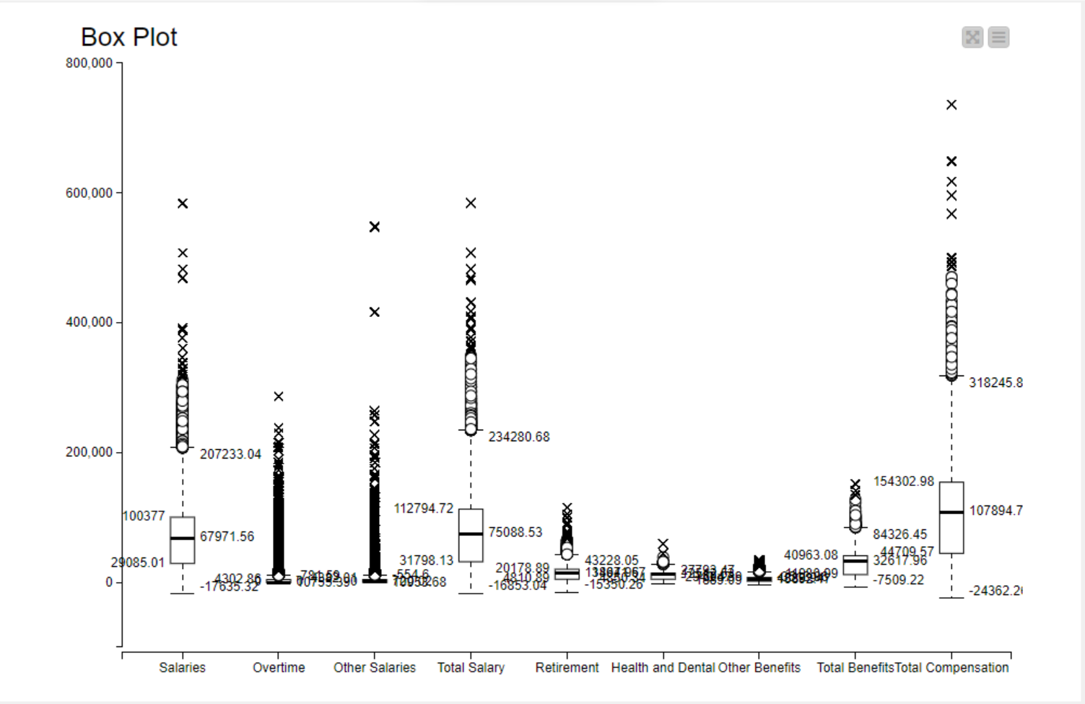

After Normalization

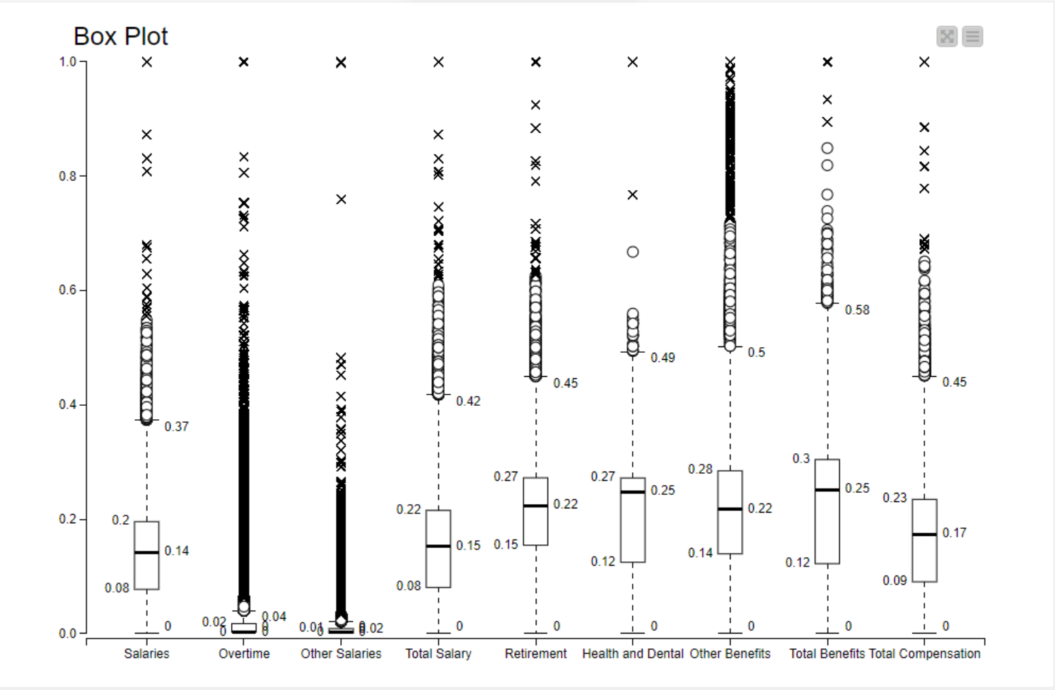

After treating Outliers

Outlier Treatment using replacement strategy where the values are replaced to the closest permitted value

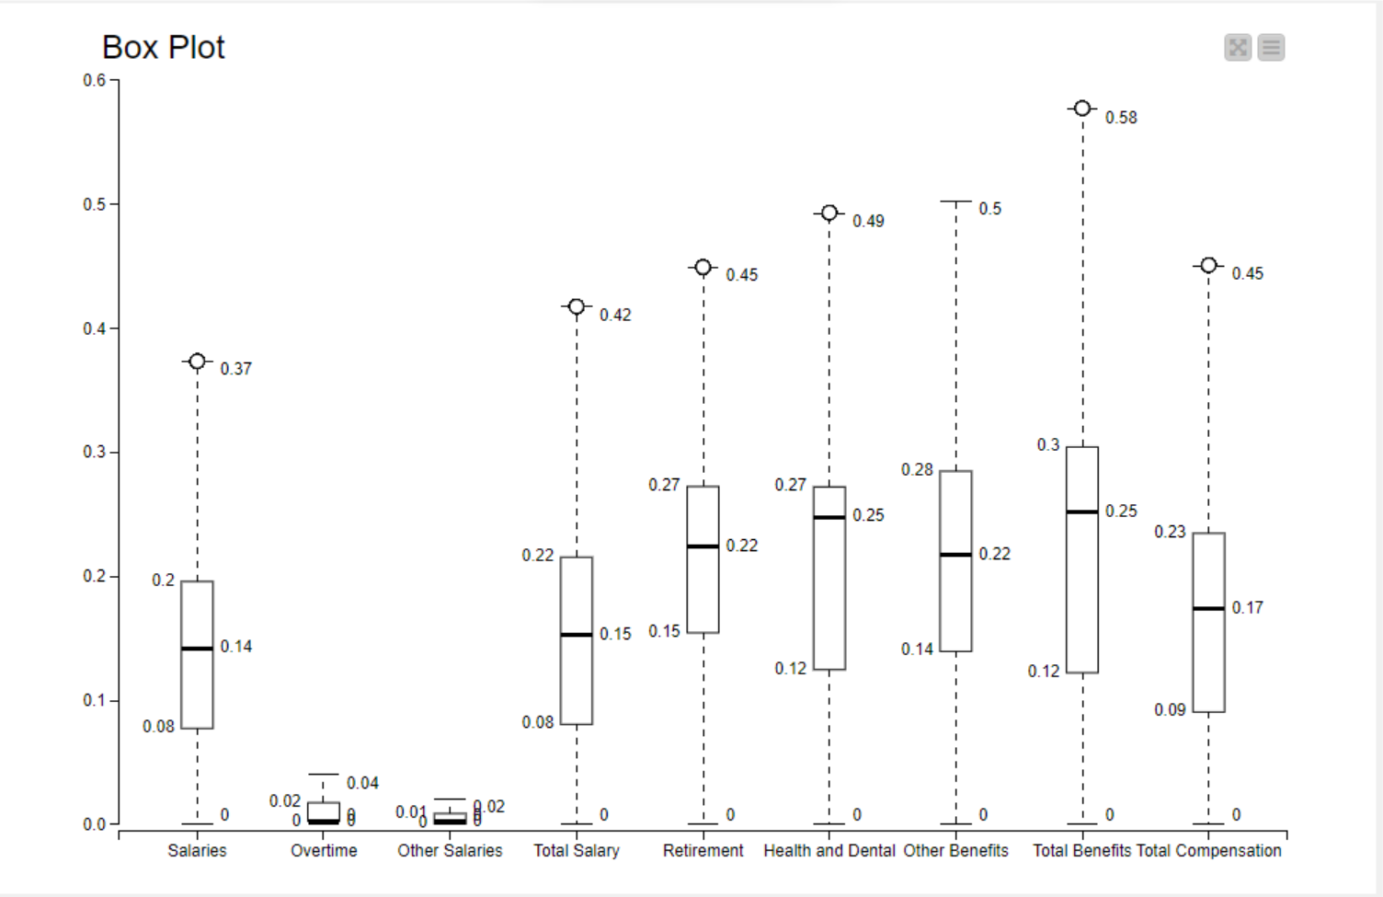

**3.2. Data Analysis**

3.2.1 Unsupervised Machine Learning Algorithm

K-means clustering is a popular unsupervised machine learning algorithm used for partitioning a dataset into a predefined number of non-overlapping clusters. The algorithm aims to group data points into clusters in such a way that the similarity (or distance) between data points within the same cluster is maximized, while the similarity between data points in different clusters is minimized. In this project, K-means will be the clustering algorithm used for unsupervised learning. The metrics used in k-means is Euclidean distance.

K = 2 (Total Number of Clusters formed are 2)



K = 3



K = 4

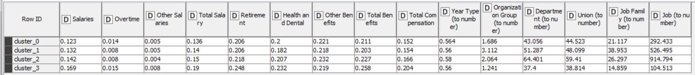

K = 5

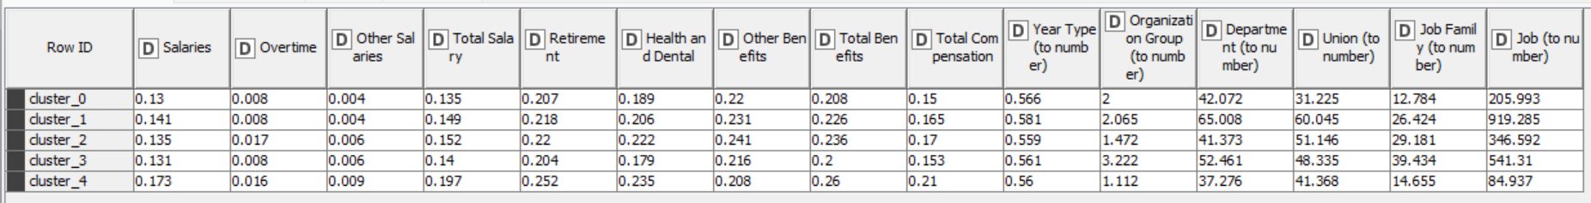

**3.2.2 Clustering Model Performance Evaluation**

The silhouette score is a metric used to evaluate the quality of clustering in unsupervised learning. It measures how similar an object is to its own cluster (cohesion) compared to other clusters (separation).

A silhouette score ranges from -1 to 1, where a higher score indicates better clustering:

* Silhouette Score of 1 indicates that clusters are well-separated.
* Silhouette Score of 0 indicates overlapping clusters.
* Silhouette Score close to -1 indicates that samples have been assigned to the wrong clusters.

K = 2

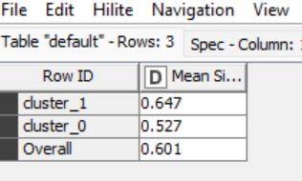

* Silhouette Score of 0.647 indicates that Cluster 1 i.e., “cluster_1” is strongly separated and good cohesion, a well defined cluster
* Silhouette Score of 0.527 indicates for Cluster 2 i.e., “ cluster_0” indicates the same with good cohesion.

K = 3

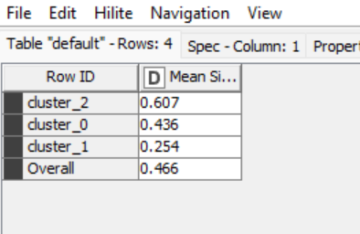

* Silhouette Score of 0.607 indicates a well-defined cluster and strong cohesion for Cluster 1 i.e., “cluster_2”
* Silhouette score of 0.436 indicates moderate cohesion and separation for Cluster 2 i.e., “cluster_0”
* Silhouette score of 0.354 indicates a weak cohesion and separation for Cluster 3 i.e., “cluster_1”

K = 4

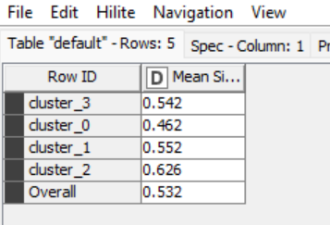

* Silhouette score of 0.542 indicates strong cohesion and separation for Cluster 1 i.e., “cluster_3”
* Silhouette score of 0.462 indicates moderate to strong cohesion and separation for Cluster 2 i.e., “cluster_0”
* Silhouette score of 0.552 indicates a strong cohesion and separation for Cluster 3 i.e., “cluster_1”
* Silhouette score of 0.626 indicates a strong cohesion and separation and it means it’s a well-defined cluster for Cluster 4 i.e., “cluster_2”

K = 5

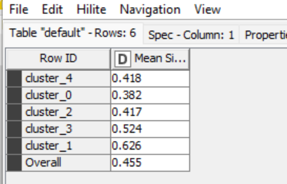

* Silhouette score of 0.418 indicates strong cohesion and separation for Cluster 1 i.e., “cluster_4”
* Silhouette score of 0.382 indicates moderate to strong cohesion and separation for Cluster 2 i.e., “cluster_0”
* Silhouette score of 0.417 indicates a strong cohesion and separation for Cluster 3 i.e., “cluster_2”
* Silhouette score of 0.524 indicates a strong cohesion and separation for Cluster 4 i.e., “cluster_3”
* Silhouette score of 0.626 indicates a strong cohesion and separation and it means it’s a well-defined cluster for Cluster 5 i.e., “cluster_1”

To be able to identify, which cluster gives the better results or performance, silhouette score will be compared for each cluster. The closer the score to 1 better the performance of the cluster.

**3.2.3 Cluster Analysis using Base Model as K-Means**

3.2.3.1 Cluster Analysis with Categorical Variables

The Kruskal-Wallis test is a non-parametric statistical test used to determine whether there are statistically significant differences between the medians of two or more independent groups. The test is appropriate when the data do not meet the assumptions required for parametric tests like ANOVA. In KNIME, Kruskal-Wallis Test is used to analyze the categorical variable. The variables that have p < 0.05, those variables will be significant in the analysis of clusters.

K = 2

Year Type



Organization Group

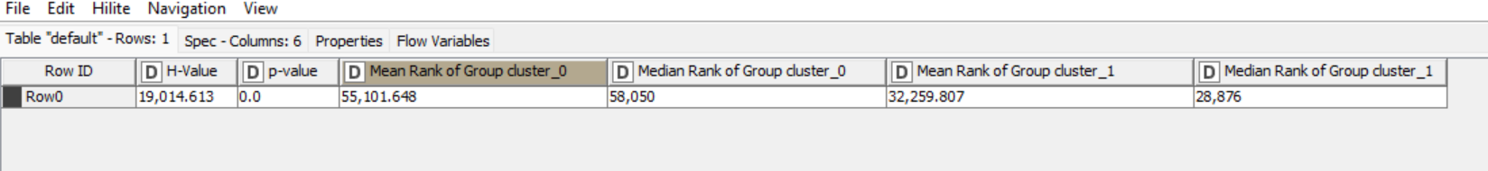

Department

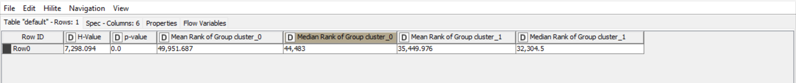

Union

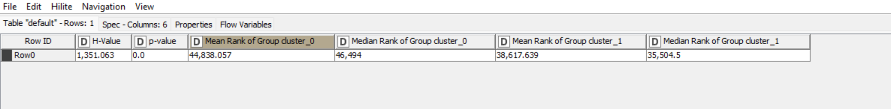

Job Family



Job

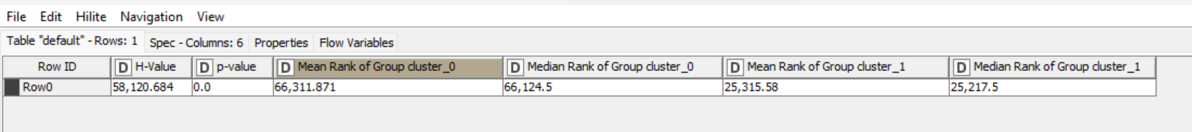

The p-value associated with the Kruskal-Wallis test is 0.0, which is less than the significance level of 0.05. Therefore, we reject the null hypothesis and conclude that there are statistically significant differences between the medians of cluster 0 and cluster 1. The mean and median ranks of each cluster indicate the average and middle positions of the observations within each group. The differences in these values between the two clusters suggest variations in the distribution of data points, contributing to the rejection of the null hypothesis. We see that all the categorical variables have p-value 0.0 which is less than 0.05 indicating that there are significant differences in the distributions of the data between cluster 0 and cluster 1 as indicated by the Kruskal-Wallis test results.

K = 3

Year Type



Organisation Group



Department



Union



Job Family



Job



The p-value associated with the Kruskal-Wallis test is 0.0, which is less than the significance level of 0.05. Therefore, we reject the null hypothesis and conclude that there are statistically significant differences between the medians of cluster 0 and cluster 1 and cluster 2. The mean and median ranks of each cluster indicate the average and middle positions of the observations within each group. The differences in these values between the two clusters suggest variations in the distribution of data points, contributing to the rejection of the null hypothesis. We see that all the categorical variables have p-value 0.0 which is less than 0.05 indicating that there are significant differences in the distributions of the data between cluster 0 and cluster 1 and cluster 2 as indicated by the Kruskal-Wallis test results.

K = 4

Year Type



Organisation Group

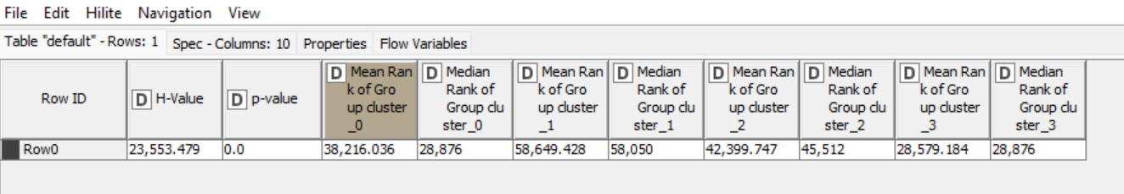

Department

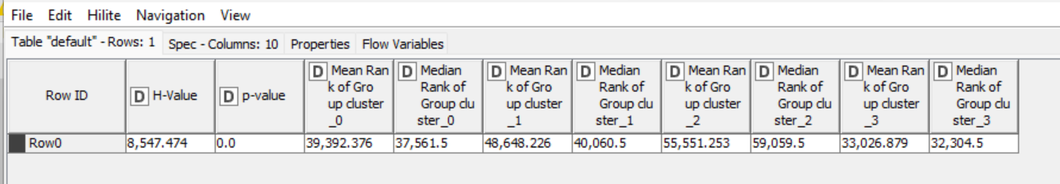

Union

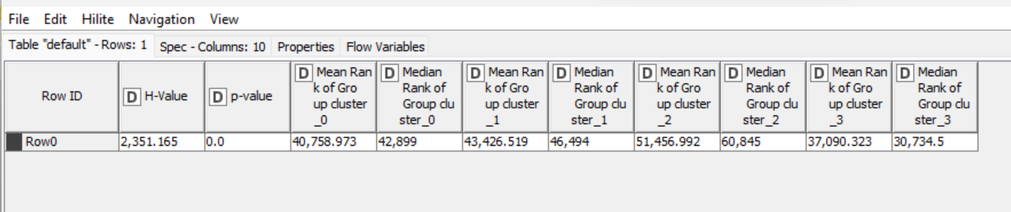

Job Family

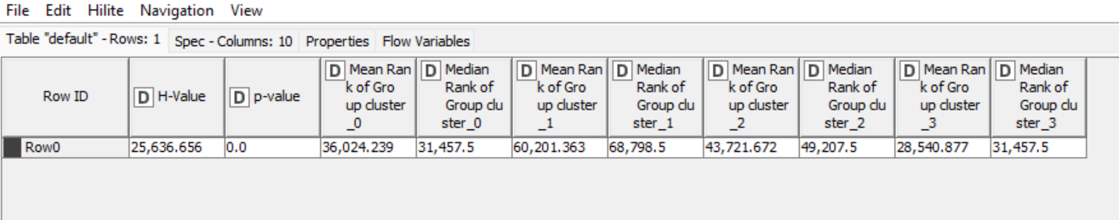

Job

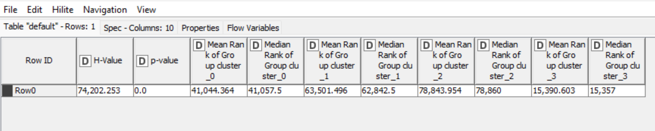

The p-value associated with the Kruskal-Wallis test is 0.0, which is less than the significance level of 0.05. Therefore, we reject the null hypothesis and conclude that there are statistically significant differences between the medians of cluster 0 and cluster 1, cluster 2 and cluster 3. The mean and median ranks of each cluster indicate the average and middle positions of the observations within each group. The differences in these values between the two clusters suggest variations in the distribution of data points, contributing to the rejection of the null hypothesis. We see that all the categorical variables have p-value 0.0 which is less than 0.05 indicating that there are significant differences in the distributions of the data between cluster 0 and cluster 1 and cluster 2 and cluster 3 as indicated by the Kruskal-Wallis test results.

K = 5

Year Type

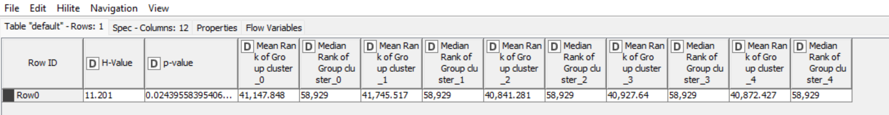

Organisation Group

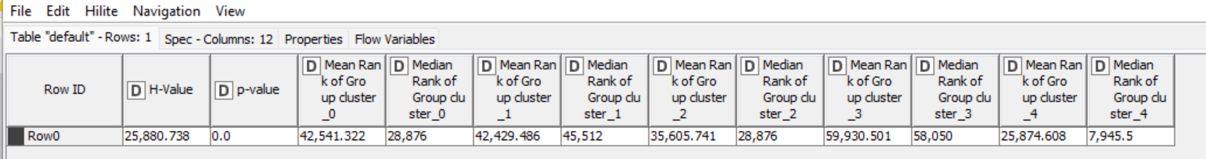

Department

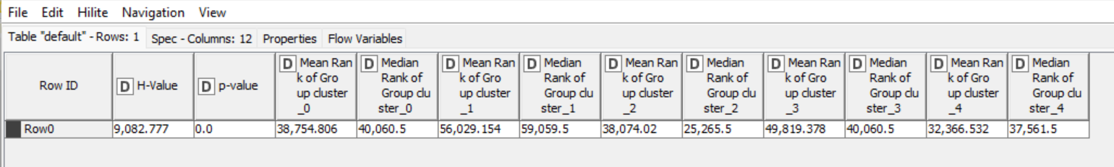

Union

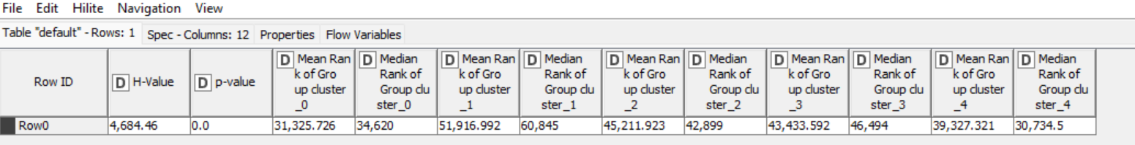

Job Family

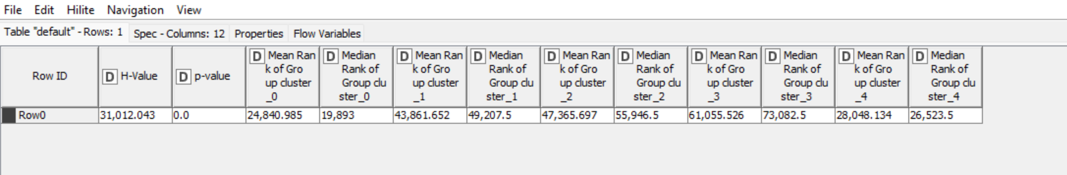

Job

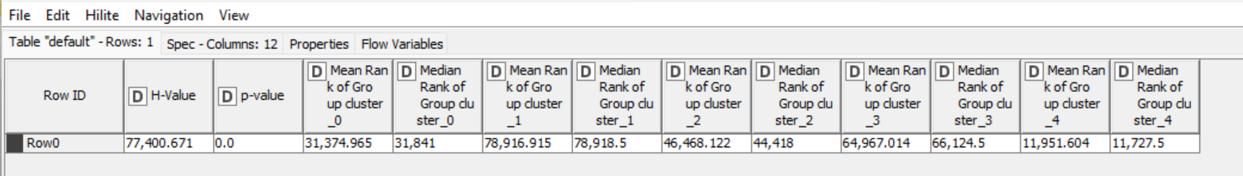

The p-value associated with the Kruskal-Wallis test is 0.0, which is less than the significance level of 0.05. Therefore, we reject the null hypothesis and conclude that there are statistically significant differences between the medians of cluster 0 and cluster 1, cluster 2 and cluster 3 and cluster 4.. The mean and median ranks of each cluster indicate the average and middle positions of the observations within each group. The differences in these values between the two clusters suggest variations in the distribution of data points, contributing to the rejection of the null hypothesis. We see that all the categorical variables have p-value 0.0 which is less than 0.05 indicating that there are significant differences in the distributions of the data between cluster 0 and cluster 1 and cluster 2 and cluster 3 and cluster 4 as indicated by the Kruskal-Wallis test results.

**3.2.3.2 Cluster analysis with Non-Categorical Variables**

In KNIME, ANOVA is used to analyze the non-categorical variables. The variables that have p < 0.05, those variables are significant in the analysis of clusters

K = 2

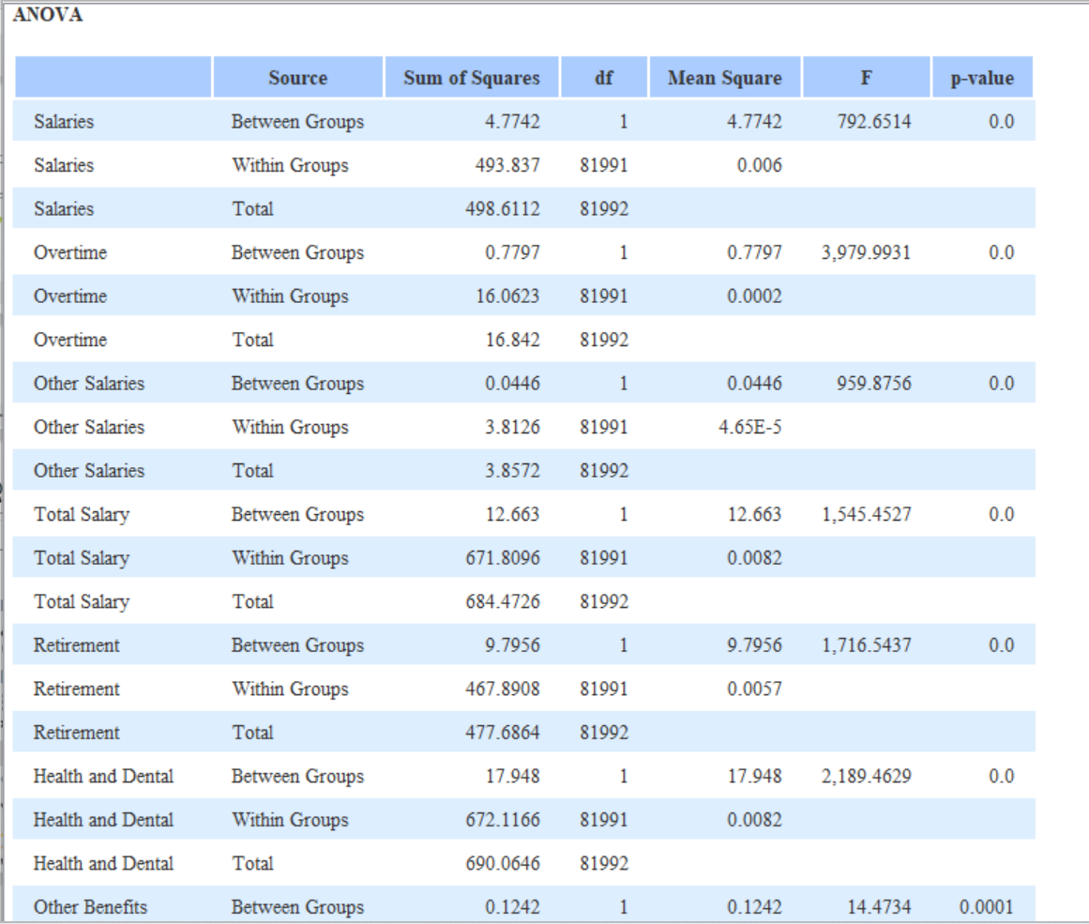

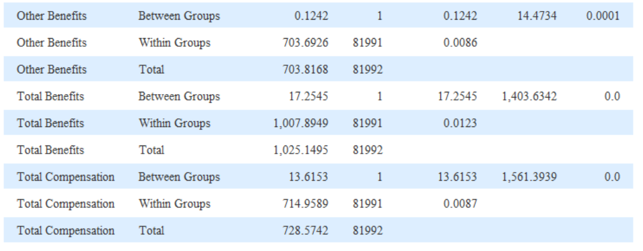

Descriptive Statistics K = 2

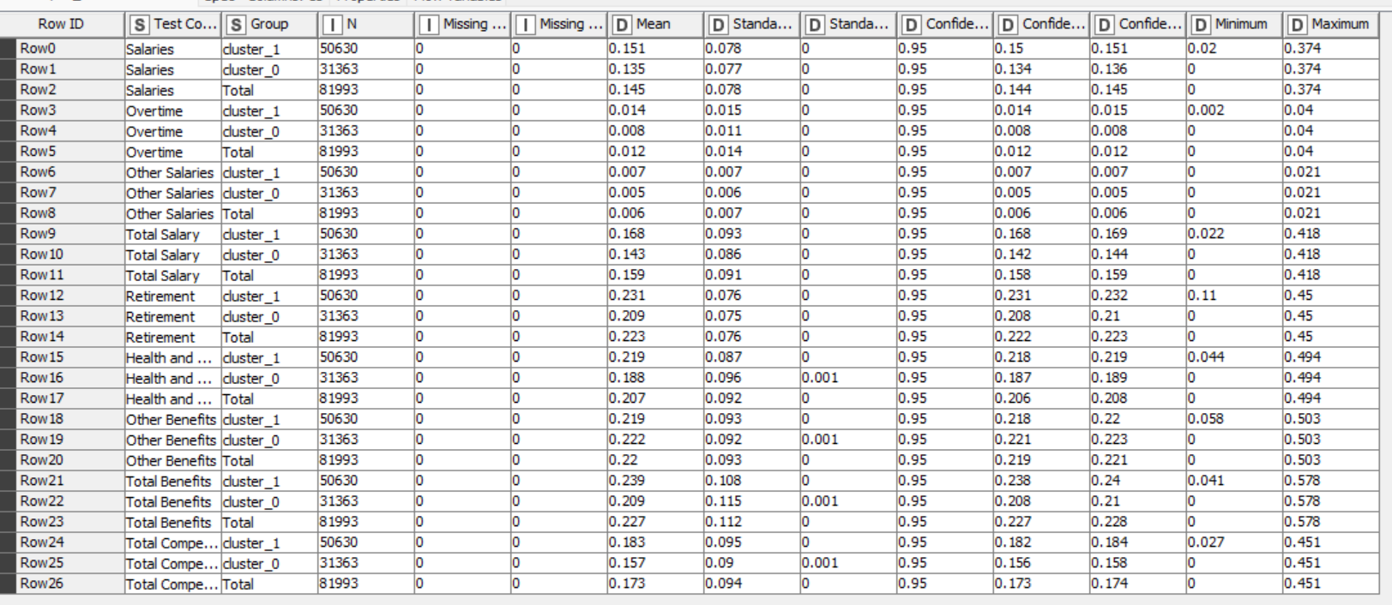

K = 3

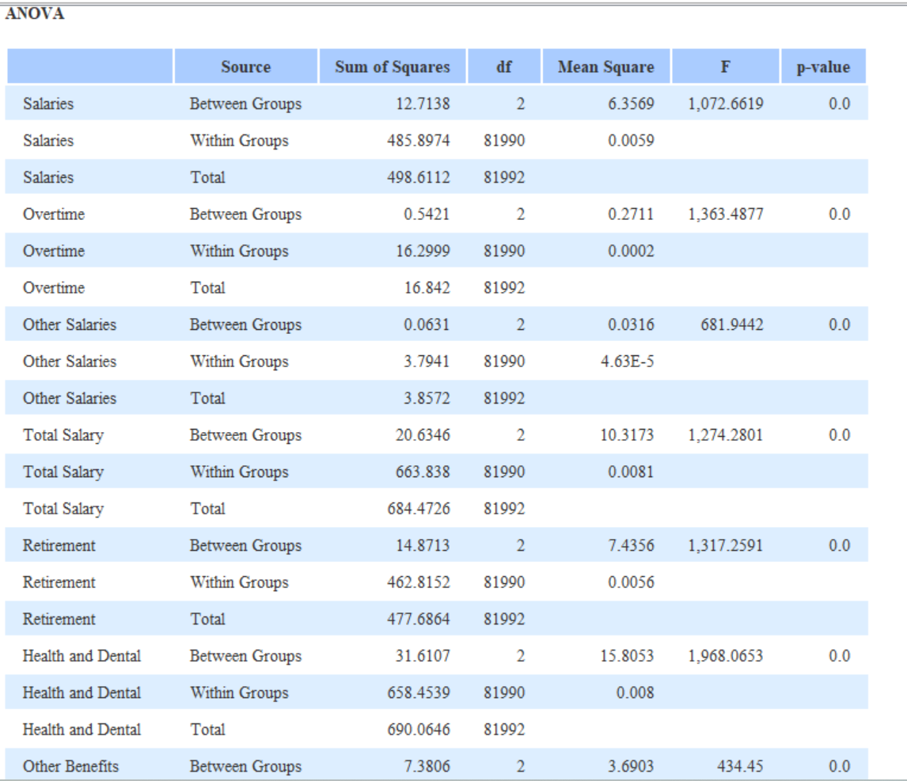

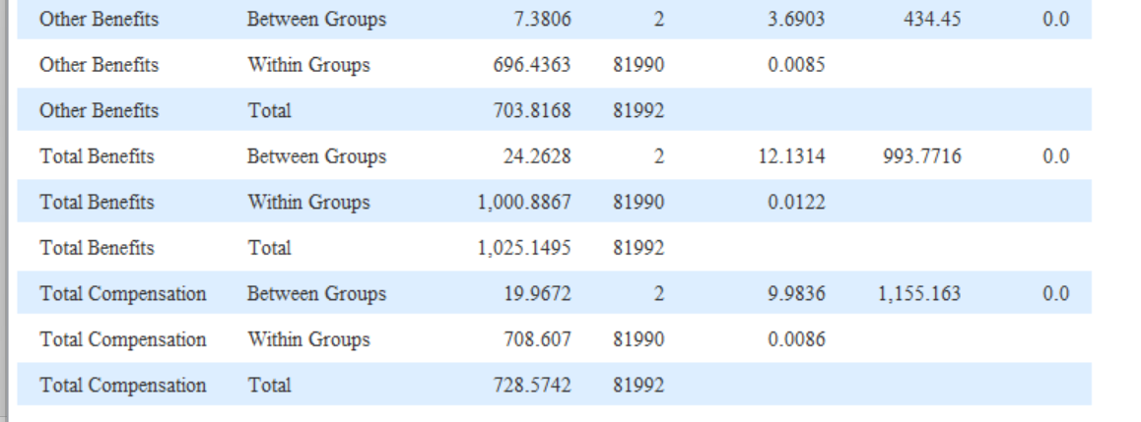

Descriptive Statistics K = 3

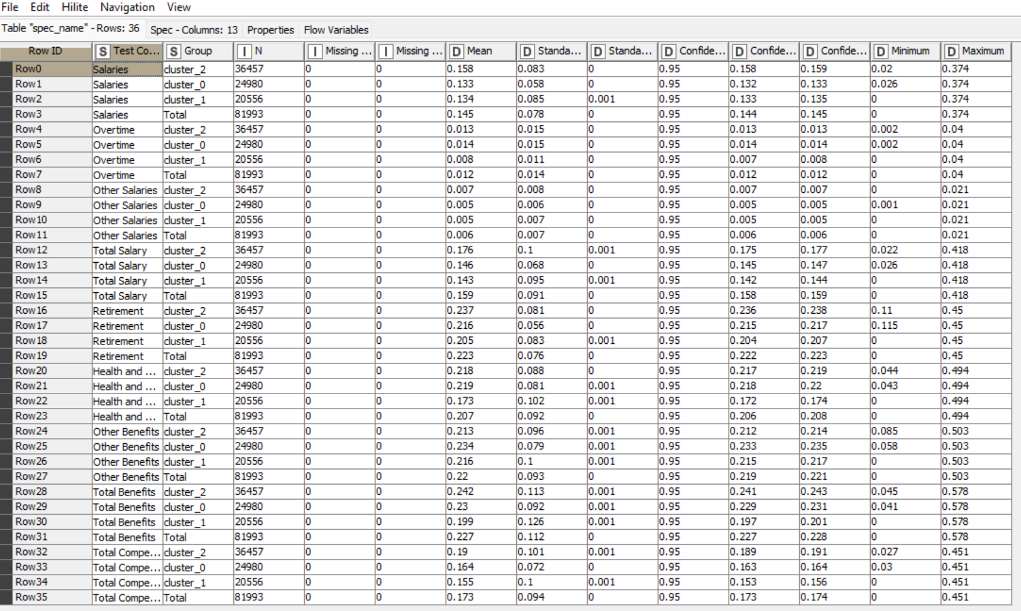

K = 4

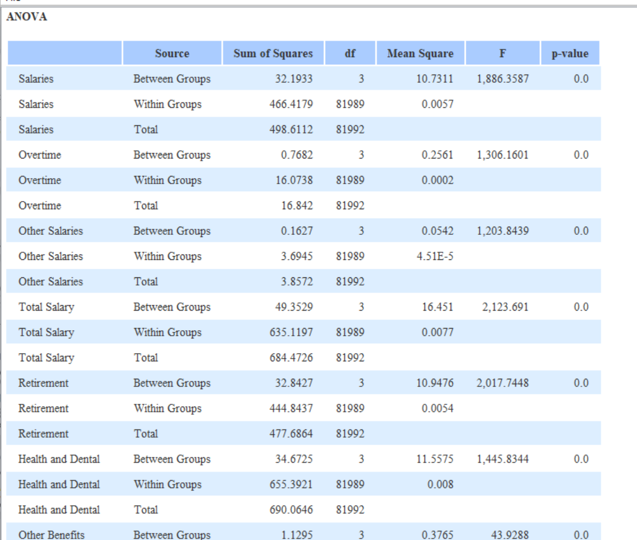

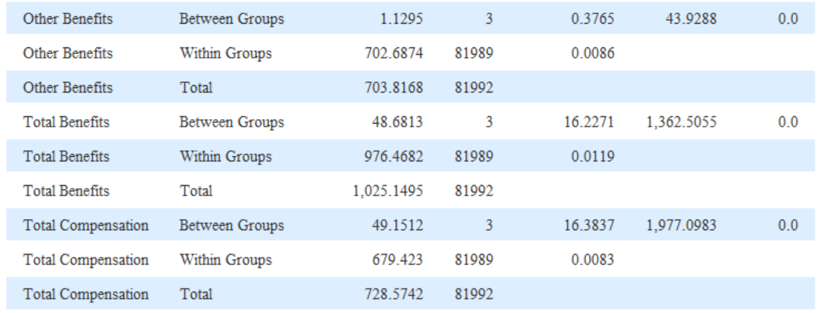

Descriptive Statistics K = 4

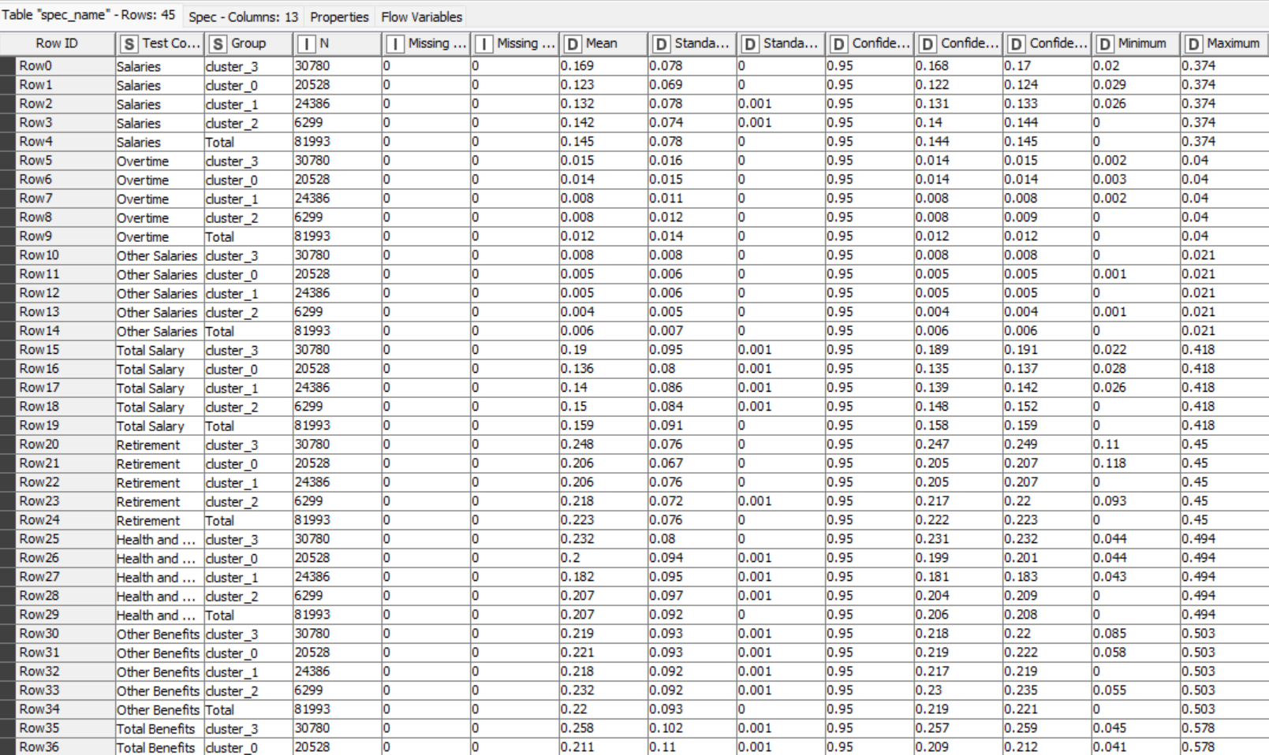

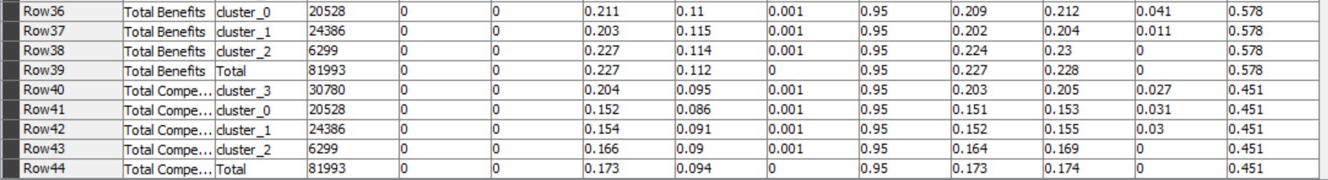

K = 5

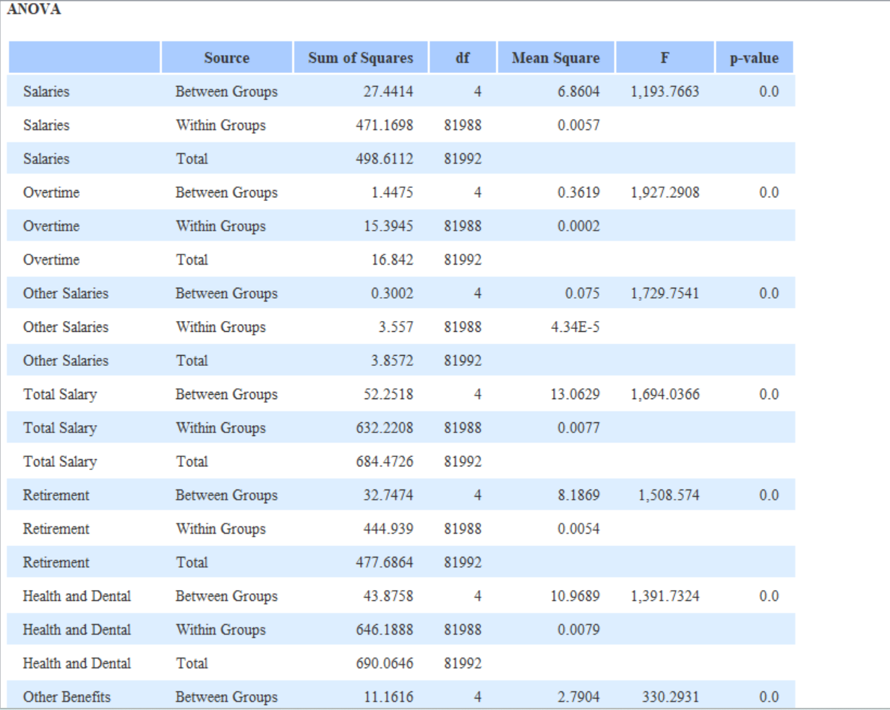

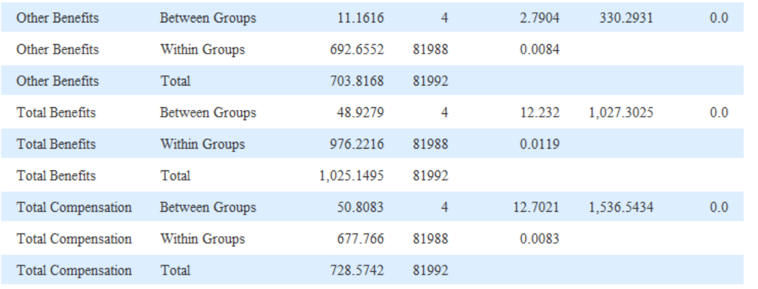

Descriptive Statistics K = 5

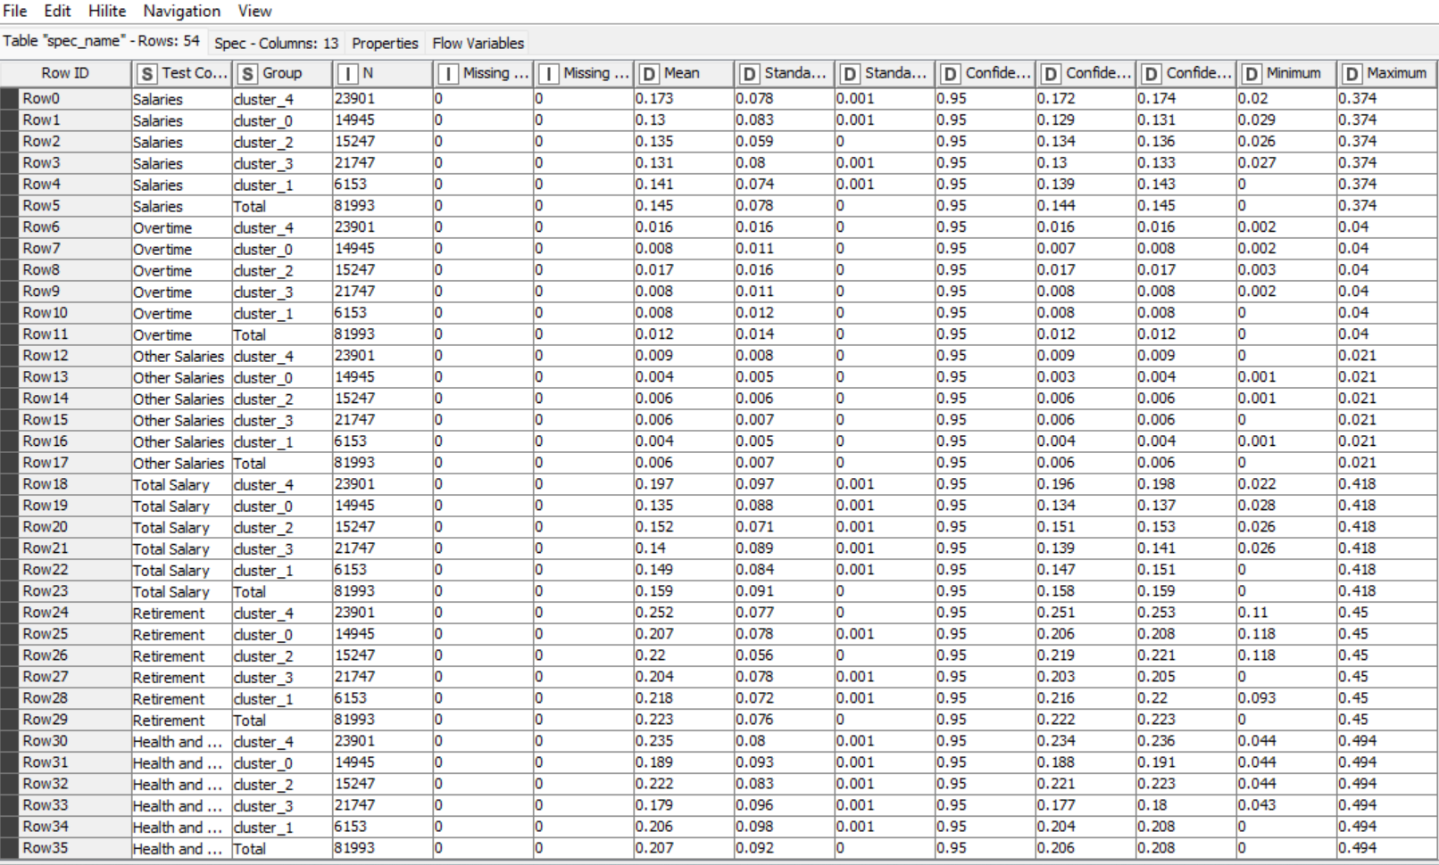

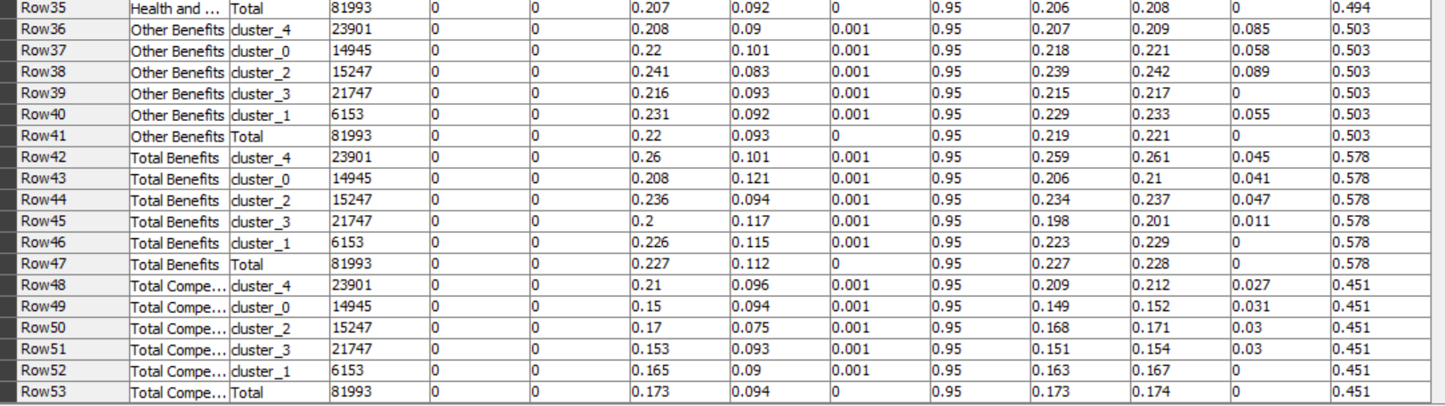

1. **Results and observation**

4.1 Appropriate Number of Segments or Clusters

|  |  |  |  |
| --- | --- | --- | --- |
| Cluster Number | Cluster | Silhouette score | Mean |
| 2 | 0,1 | |  | | --- | | 0.647 | | 0.527 | |  | | 0.601 |
| 3 | 0,1,2 | |  | | --- | | 0.607 | | 0.436 | | 0.254 | |  | | 0.466 |
| 4 | 0,1,2,3 | |  | | --- | | 0.542 | | 0.469 | | 0.552 | | 0.627 | |  | | 0.532 |
| 5 | 0,1,2,3,4 | |  | | --- | | 0.418 | | 0.382 | | 0.417 | | 0.524 | | 0.626 | | 0.455 |

The silhouette score of all the clusters formed are given and by looking at the table we can say that the highest silhouette score is of cluster 2 and is well defined, separated and has the most cohesion, and is ultimately the most appropriate cluster of the lot for data analysis of the employee compensation data.

4.2 Cluster analysis

4.2.1 Categorical Variables

It has been observed that all the variables are contributing to the cluster for making the compensation data. This is because the p-value is less than 0.05 (confidence level at 95% for the model) which in turn tells that all the categorical variables are significant for the process of making the clusters.

4.2.2 Non-Categorical Variables

It has been observed that all the variables are contributing to the cluster for making the compensation data. This is because the p-value is less than 0.05 (confidence level at 95% for the model) which in turn tells that all the non-categorical variables are significant for the process of making the clusters.

1. **Managerial Insights**

The managerial insights obtained from the employee compensation data and clustering it using k-means is as follows:

1. Various factors depend on contributing to employee compensation such as retirement benefits, health and dental among others.
2. All of these are interconnected and directly contribute to the total compensation of the employees.
3. Overtime may not necessarily mean a significant increase in total compensation as seen in clusters: K = 2, K = 3, K = 4 and K = 5.
4. It is also indicated many particular jobs result in higher salaries of employees and may require less overtime.
5. All of these factors contribute to HR and retention of employees because compensation is crucial for keeping employees happy and satisfied with the workplace.
6. As an HR we must pay attention to the overtime of employees in that case appropriately compensating them side by side.